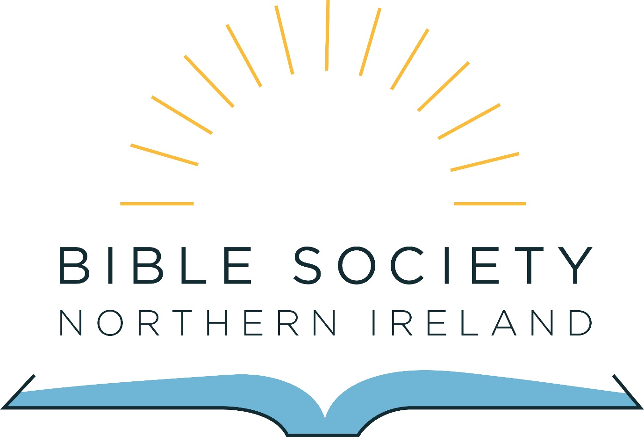

Information Pack for the appointment of a
Communications and Fundraising Manager

April 2019

Contents:

2. Introduction from the General Secretary

3. About Bible Society in Northern Ireland

4. Overview of the role of Communications and Fundraising Manager

5. Who are we looking for

7. Terms and Conditions and how to apply

Introduction from the General Secretary

Thank you for your interest in joining our team here at the Bible Society in Northern Ireland.

I am really excited at the potential of this new role; the successful candidate will have the opportunity to not only share how amazing the Bible is but also about the amazing work that Bible Societies around the world are involved in.

The writer to the Hebrews understood the importance of the Word of God when they wrote ‘for the word of God is alive and active. Sharper than any double-edged sword’ (Hebrews 4:12) (NIV). The Bible is as relevant today as ever and it is wonderful to be part of the work of the Bible Society family globally and here in our context in Northern Ireland.

It is our prayer that the right person will be prompted to apply.

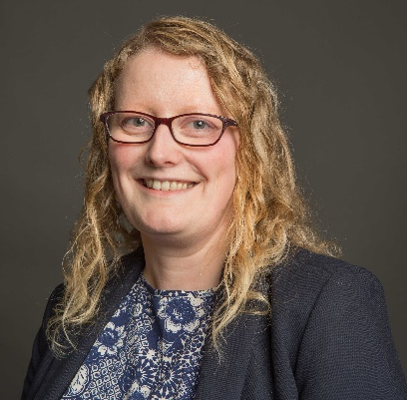
Every blessing

Catherine Little
General Secretary

About Bible Society in Northern Ireland

Bible Society activity started in Belfast in 1807. We are a long-established organisation that seeks to ‘Reach Everyone with God’s Word’.

Bible Society in Northern Ireland is part of a global fellowship called United Bible Societies, there are over 150 Bible Societies around the world with activity in almost every country in the world.

In Northern Ireland we raise financial and prayer support for Bible Society projects all over the world. In 2019 we are supporting 39 different projects in 35 different countries, providing approximately £415,000 for Bible translation, publication and distribution, for literacy work using the Bible as a learning tool and for Bible engagement and advocacy. We also support Bible engagement work here in Northern Ireland working in collaboration with others to increase Scripture access and engagement for children, young people and adults. Look at biblesocietyni.co.uk/what-we-do/where-we-support/ for further information on where we are supporting.

We are in the first year of a new strategic plan for 2019 to 2021. At the heart of our strategic direction for the next three years are five aims:

- We want to grow awareness of our work to reach everyone with God’s Word
- We want to increase and develop the support base for our work by increasing the number of donors and developing new ways to generate funds
- We want to increase our financial support of Bible mission globally through UBS and locally through collaboration and partnership with others here in Northern Ireland
- We want to promote Bible Engagement here in Northern Ireland
- We want to have best practice governance, finance and administration policies and procedures in place to ensure effective and efficient management of Bible Society in Northern Ireland.

More information about our work can be found on our website www.biblesocietyni.co.uk

Overview of the role of Communications and Fundraising Manager

Key Purpose of the post:

To be responsible for all communication from Bible Society in Northern Ireland which will grow awareness, increase the support base and develop the financial and prayer support of our work.

Key roles:

- Lead and develop our communication strategy
This individual will steer our communication strategy to grow awareness of Bible Society in Northern Ireland as well as increase and develop our support base. We have wonderful stories to share of Bible Society work locally and globally, this role will help Bible Society NI share stories well.

- Co-ordinate and develop the message of the Bible Society in Northern Ireland
The postholder will develop our message through our website, print materials and digital platforms. This will involve all types of communication and will require strong storytelling, good attention to detail, editing, liaising with designers and printers and online activity.

- Raising financial support from new and existing sources
This individual will bring their fundraising experience to what we already do to increase our financial support. They will lead our income generation through direct mail, regular giving campaigns, legacy fundraising, trust fund and major donor support.

- Evaluate, review and analyse our communications and fundraising to maximise our influence and engagement
This role will help Bible Society in Northern Ireland have excellent communication and fundraising that is dynamic and appropriate to its audience. They will help us be relevant and effective in telling Northern Ireland what we do.

- To assist with the general work of the Bible Society in Northern Ireland in fulfilling its mission of ‘Reaching everyone with God’s Word’
The postholder will have a flexible approach to work and will be available to represent the Society at events, conferences and other occasions which require a staff presence.

This is not an exhaustive list, it acts as a guide which may be amended after consultation with the postholder.

Who are we looking for

We are looking for someone who loves the Bible, who is a committed Christian and can demonstrate the following criteria through their application to the role of Communications and Fundraising Manager.

 | Essential | Desirable
Qualifications | - Degree (or equivalent vocational level of knowledge) | - Fundraising qualification  - Communications qualification
Experience | - Experience in a communication role with a charity  - Experience in a fundraising position with a charity  - Experience of online, print, and digital content development  - Experience of website management  - Experience of social media for professional purposes  - Project management experience | - 2 years’ experience in a communication role with a charity  - 2 years’ experience in a fundraising position with a charity  - Knowledge of the Northern Ireland Charity sector  - Experience of working across church denominations in Northern Ireland  - Understanding of GDPR  - Experience of developing policies and procedures
Skills / Abilities | - Excellent communication skills both written and verbal, including communicating with different audiences  - Strong administrative and organisational skills  - Ability to inspire, involve and motivate others  - Excellent IT skills with proficiency in Microsoft Office  - Ability to work as part of a team  - Creative, innovative and able to use own initiative
Personal Qualities | - A strong personal Christian faith reflected in their commitment to the Bible and its mission  - Results driven  - Self-starter and can work independently  - Flexible approach to work  - An outgoing, approachable, warm and charismatic personality  - Willing to work anti-social hours as required
Other Comments | - Full UK Driving licence and confidence to drive

Criteria may be enhanced to facilitate shortlisting for the interview process.

Terms and Conditions and how to apply

Job Title: Communications and Fundraising Manager, Bible Society in Northern Ireland

Reporting to: General Secretary

Responsible for: Developing communication from the Bible Society in Northern Ireland in print, online and through digital platforms

Location: Based in Belfast with travel throughout Northern Ireland. Occasional travel within the UK, Ireland and overseas may be required.

Hours: 35 hours per week (Mon – Fri, 9am – 5pm) with some evening and weekend work required.

Salary: Point 27 on the NJC pay scale (£24,657 per annum)

Pension: 4% employee contribution and 8% employer contribution

Holiday Entitlement: 25 days per annum plus 12 Statutory Days

Duration: (6-month probation) 2 Year Fixed Term Contract

To apply please complete our application form which can be downloaded from our website.

Please return your completed application form by email to catherine@biblesocietyni.co.uk or by post marked Private and Confidential to Catherine Little, Bible Society NI, 27 Howard Street, Belfast, BT1 6NB before 12noon on the 29th April 2019.

Interviews will take place during the week beginning 20th May 2019 in Belfast.

It is an occupational requirement that the person appointed must be a Christian and confirm their agreement to the aims and objectives of Bible Society in Northern Ireland.

Any information supplied will be used for the purposes of the recruitment process only.

