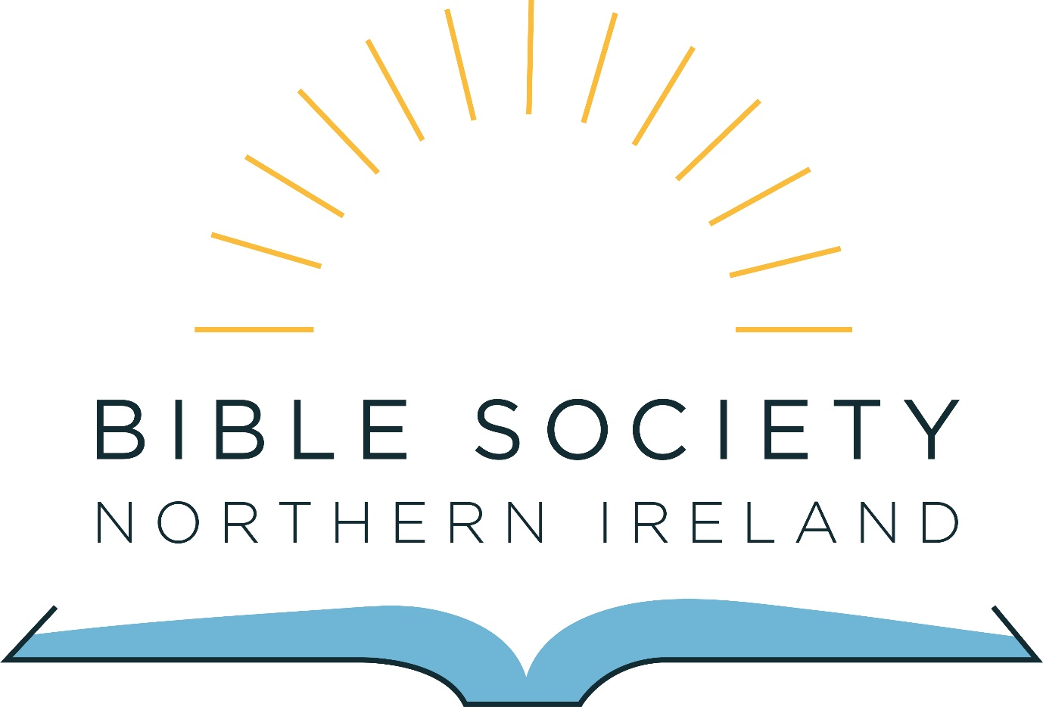

Information Pack for the appointment of a
Community Partnerships Manager

January 2019

Contents:

2. Introduction from the General Secretary

3. About Bible Society in Northern Ireland

4. Overview of the role of Community Partnerships Manager

5. Who are we looking for

7. Terms and Conditions and how to apply

Introduction from the General Secretary

Thank you for your interest in joining our team here at the Bible Society in Northern Ireland.

I am really excited at the potential of this new role; the successful candidate will have the opportunity to not only share how amazing the Bible is but also about the amazing work that Bible Societies around the world are involved in.

The writer to the Hebrews understood the importance of the Word of God when they wrote ‘for the word of God is alive and active. Sharper than any double-edged sword’ (Hebrews 4:12) (NIV). The Bible is as relevant today as ever and it is wonderful to be part of the work of the Bible Society family globally and here in our context in Northern Ireland.

It is our prayer that the right person will be prompted to apply.

Every blessing

Catherine Little
General Secretary

About Bible Society in Northern Ireland

Bible Society activity started in Belfast in 1807. We are a long-established organisation that seeks to ‘Reach Everyone with God’s Word’.

Bible Society in Northern Ireland is part of a global fellowship called United Bible Societies, there are over 150 Bible Societies around the world with activity in almost every country in the world.

In Northern Ireland we raise financial and prayer support for Bible Society projects all over the world. In 2019 we are supporting 39 different projects in 35 different countries, providing approximately £400,000 for Bible translation, publication and distribution, for literacy work using the Bible as a learning tool and for Bible engagement and advocacy. We also support Bible engagement work here in Northern Ireland working in collaboration with others to increase Scripture access and engagement for children, young people and adults. Look at biblesocietyni.co.uk/what-we-do/where-we-support/ for further information on where we are supporting.

We are at the beginning of a new strategic plan for 2019 to 2021. At the heart of our strategic direction for the next three years are five aims:

- We want to grow awareness of our work to reach everyone with God’s Word
- We want to increase and develop the support base for our work by increasing the number of donors and developing new ways to generate funds
- We want to increase our financial support of Bible mission globally through UBS and locally through collaboration and partnership with others here in Northern Ireland
- We want to promote Bible Engagement here in Northern Ireland
- We want to have best practice governance, finance and administration policies and procedures in place to ensure effective and efficient management of Bible Society in Northern Ireland.

More information about our work can be found on our website www.biblesocietyni.co.uk

Overview of the role of Community Partnerships Manager

Key Purpose of the post:

To develop partnership opportunities for Bible Society in Northern Ireland across our local community in order to grow awareness of our work, increase mission sustainability and enhance the profile of the Bible with:
- Churches
- Church groups
- Schools
- Para-church organisations
- Mission agencies

Key roles:

- Development and delivery of a community partnership strategy
This individual will develop new ways of engaging with new and existing stakeholders of our work across Northern Ireland to see the profile of the organisation increase. This individual will lead on the BIBLE 2020 initiative here in Northern Ireland.

- Church Engagement
This individual will work alongside other members of the Bible Society NI team to engage churches, church groups and individuals with our work creating an atmosphere of increased awareness and support across the faith community in Northern Ireland.

- Volunteer involvement
The postholder will develop a culture of volunteering within Bible Society NI creating a network of Bible Society NI Champions across Northern Ireland.

- Mission Sustainability
The postholder will encourage community fundraising for Bible Society NI throughout Northern Ireland and develop opportunities for supporters to gather and learn more about our work.

- Bible Engagement
This role will promote Bible engagement across Northern Ireland. The postholder will help create collaboration between Bible Society NI and other organisations to further Bible engagement and literacy.

Speak and communicate on behalf of Bible Society in Northern Ireland

Attend events and conferences on behalf of the Bible Society in Northern Ireland.

This is not an exhaustive list, it acts as a guide which may be amended after consultation with the postholder.

Who are we looking for

We are looking for someone who loves the Bible, who is a committed Christian and can demonstrate the following criteria through their application to the role of Community Partnerships Manager.

 | Essential | Desirable
Qualifications | - Degree (or equivalent vocational level of knowledge) | - Theology or Biblical studies qualification
Experience | - Knowledge of the Northern Ireland church and para church context  - Communication with a variety of audiences and contexts  - Excellent presentation skills  - Proven experience of involving volunteers  - Fundraising and event organisation experience  - Project management experience | - Knowledge of the Northern Ireland Charity sector  - Experience of working across church denominations in Northern Ireland  - Evidence of strategic thinking and planning
Skills / Abilities | - Excellent communication skills both written and verbal  - Strong administrative and organisational skills  - Ability to inspire, involve and motivate others  - Excellent IT skills and knowledge of social media  - Strong networking skills  - Ability to work as part of a team  - Creative, innovative and able to use own initiative | - Creating video content for use on social media and online
Personal Qualities | - A strong personal Christian faith reflected in their commitment to the Bible and its mission  - Results driven  - Self-starter and can work independently  - Flexible approach to work  - An outgoing, approachable, warm and charismatic personality  - Willing to work anti-social hours as required
Other Comments | - Full UK Driving licence and confidence to drive

Criteria may be enhanced to facilitate shortlisting for the interview process.

Terms and Conditions and how to apply

Job Title: Community Partnership Manager, Bible Society in Northern Ireland

Reporting to: General Secretary

Responsible for: Developing, growing and maintaining partnerships across Northern Ireland on behalf of the Bible Society in Northern Ireland.

Location: Based in Belfast with travel throughout Northern Ireland. Occasional travel within the UK, Ireland and overseas may be required.

Hours: 35 hours per week (Mon – Fri, 9am – 5pm) with some evening and weekend work required.

Salary: Point 27 on the NJC pay scale (£24,657 per annum)

Pension: 4% employee contribution and 8% employer contribution

Holiday Entitlement: 25 days per annum plus 12 Statutory Days

Duration: (6-month probation) Fixed term until 31st December 2021

To apply please complete our application form which can be downloaded here.

Please return your completed application form by email to catherine@biblesocietyni.co.uk or by post marked Private and Confidential to Catherine Little, Bible Society NI, 27 Howard Street, Belfast, BT1 6NB before 12noon on the 28th January 2019.

Interviews will take place on Friday 8th February in Belfast.

It is an occupational requirement that the person appointed must be a Christian and confirm their agreement to the aims and objectives of Bible Society in Northern Ireland.

Any information supplied will be used for the purposes of the recruitment process only.

